Jurnal Modul 14
Nama : Florensius Hutagalung
NIM : 103032330113
Kelas : IT – 47 – 05

Output
Tampilan Login
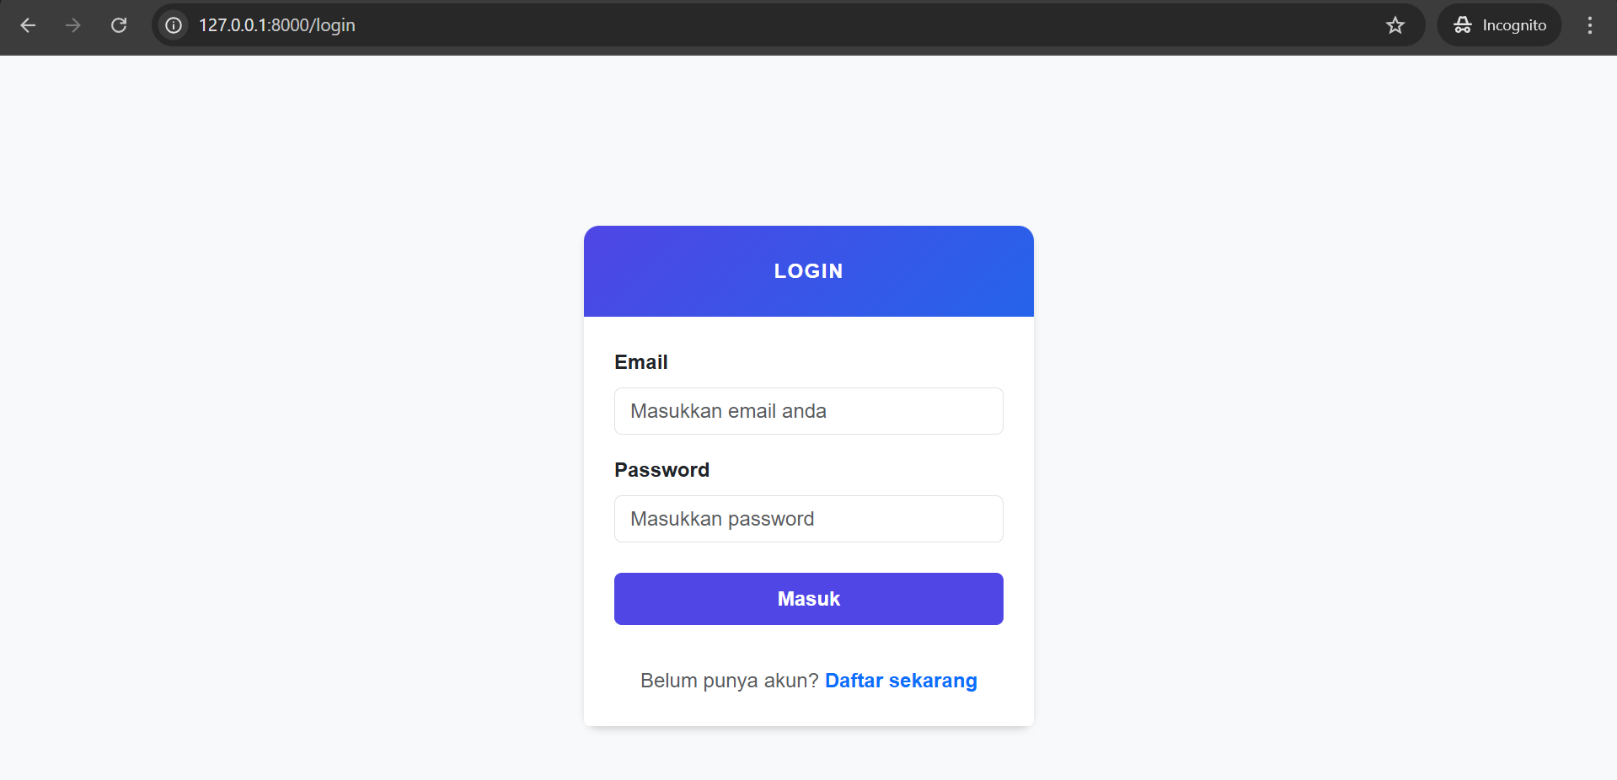
Tampilan Register
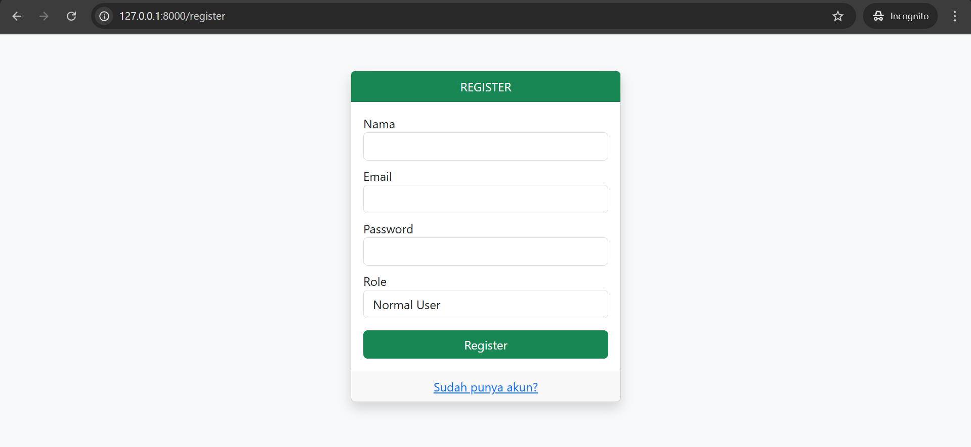
Tampilan Admin
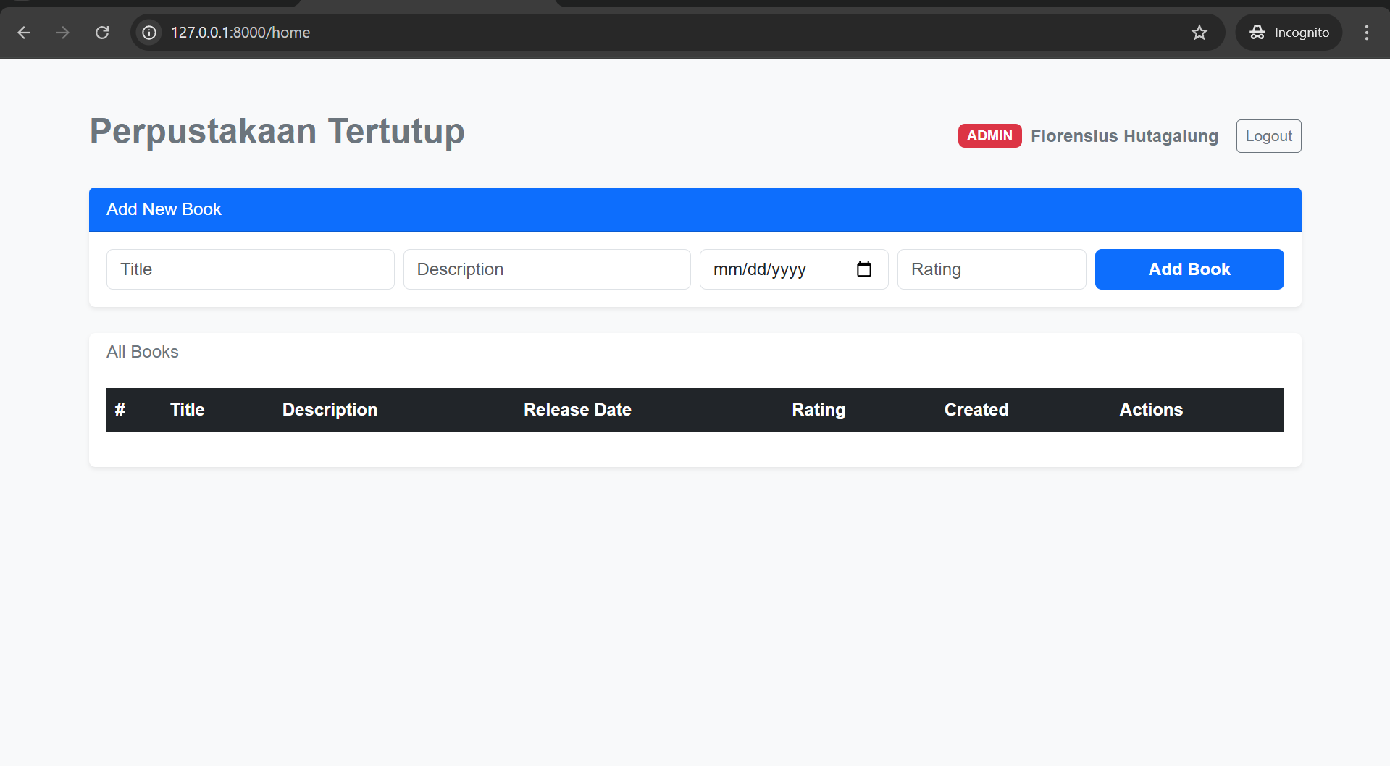
Tambah buku
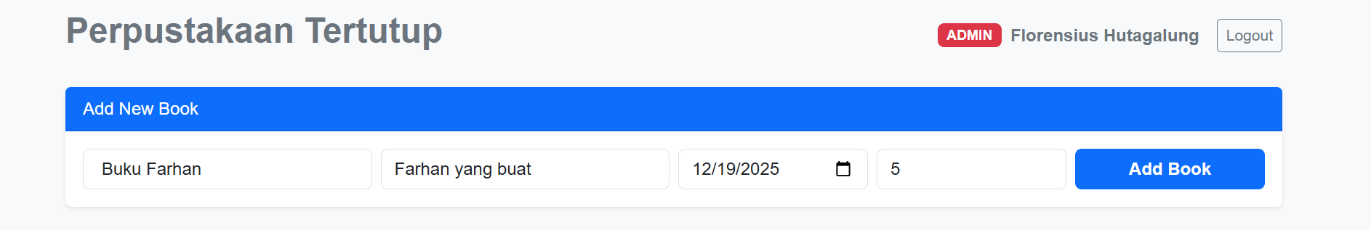
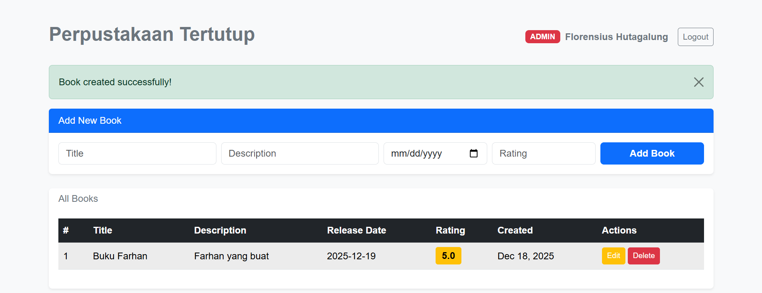

Edit Buku
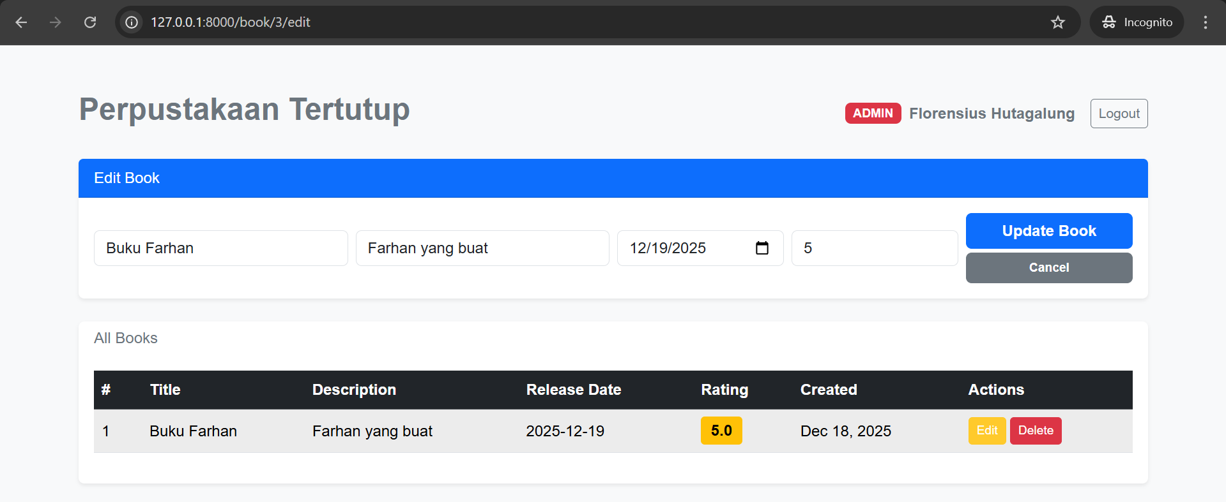
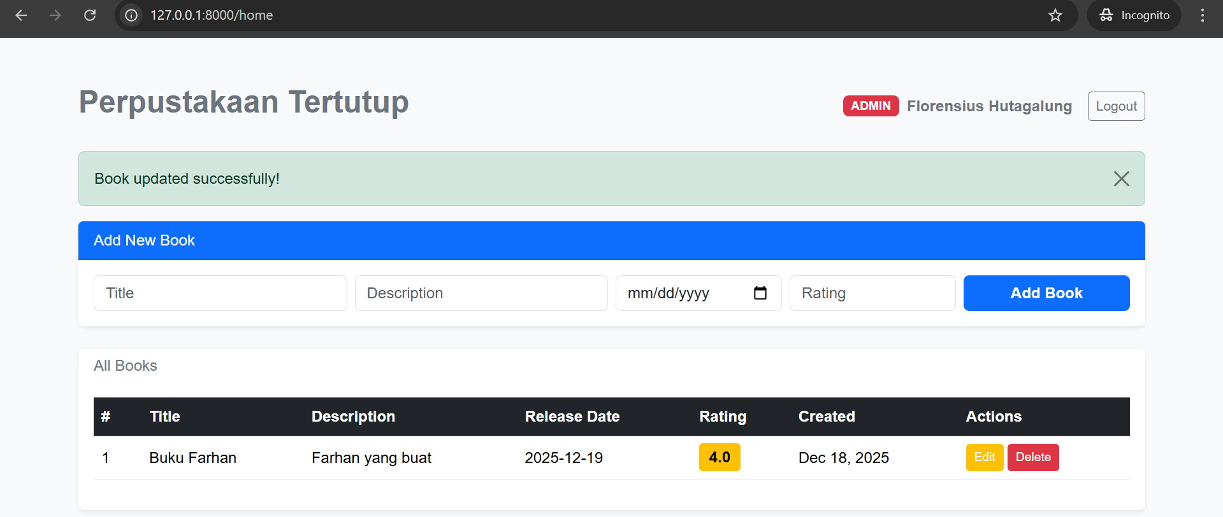
Hapus buku
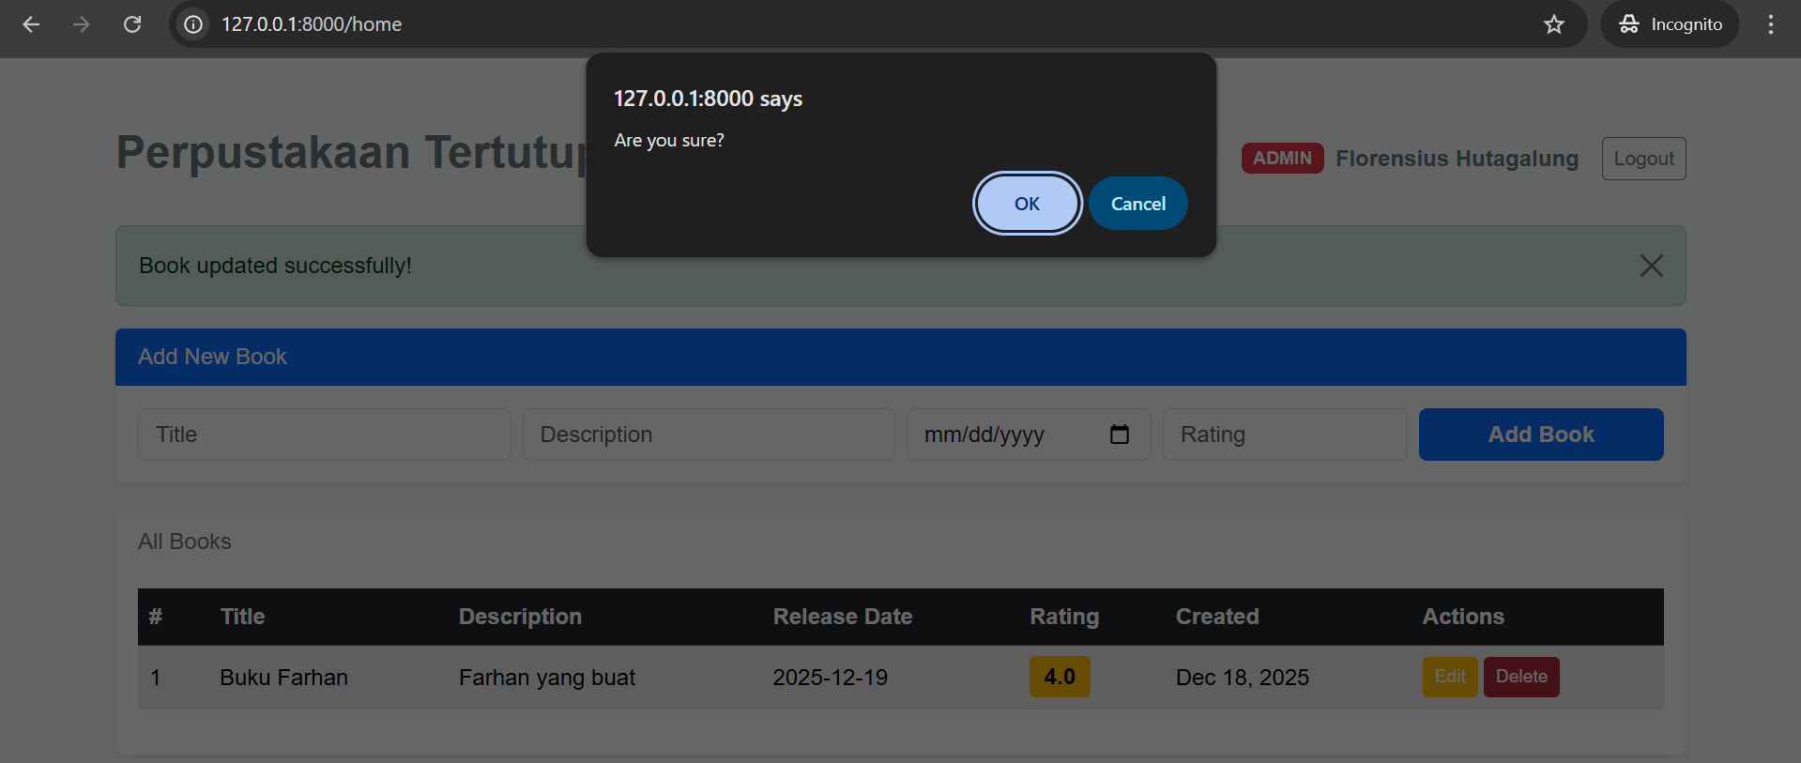
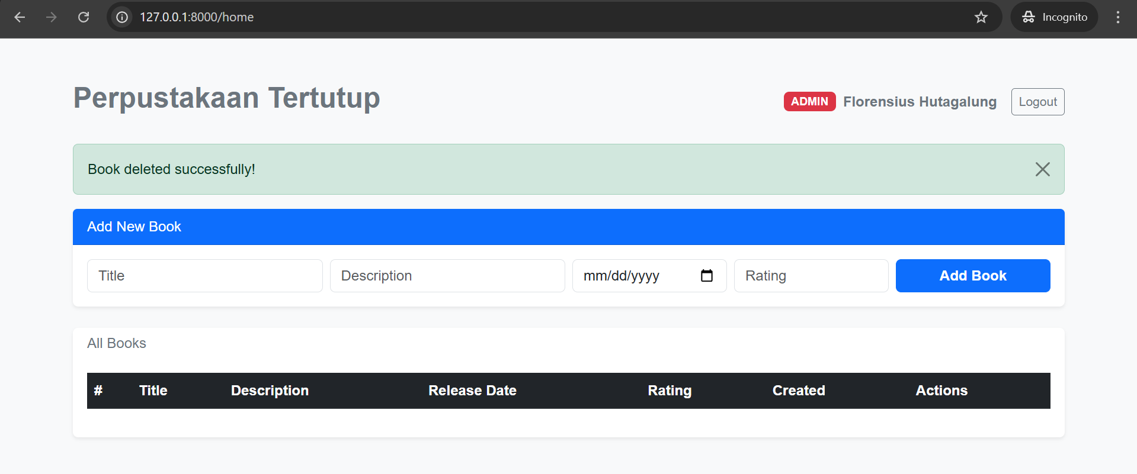
Tampilan Normal User
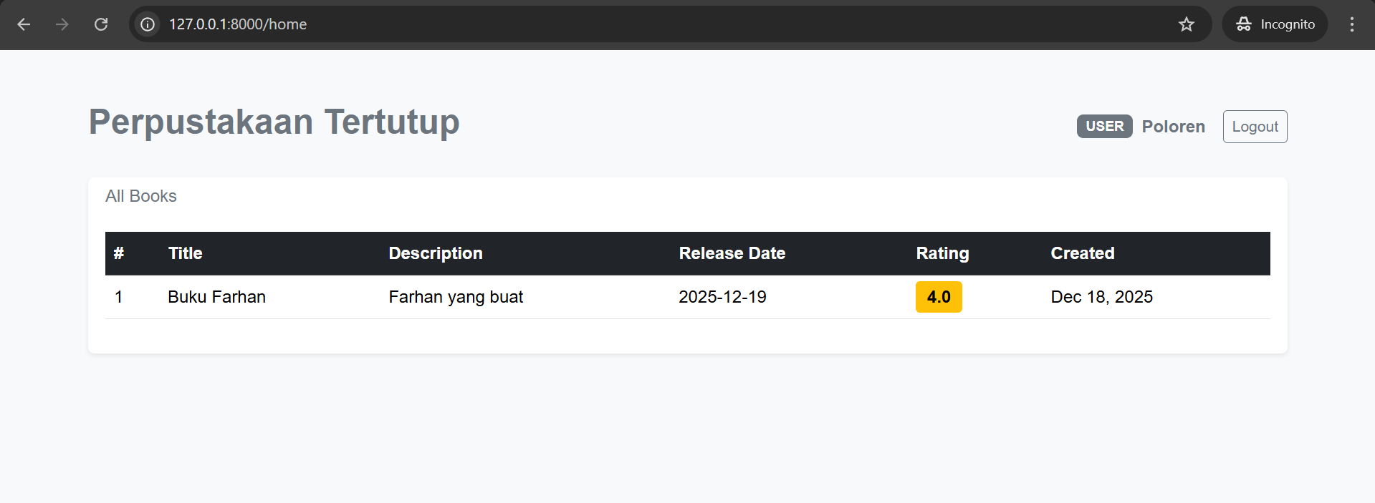
Database : jurnal_14
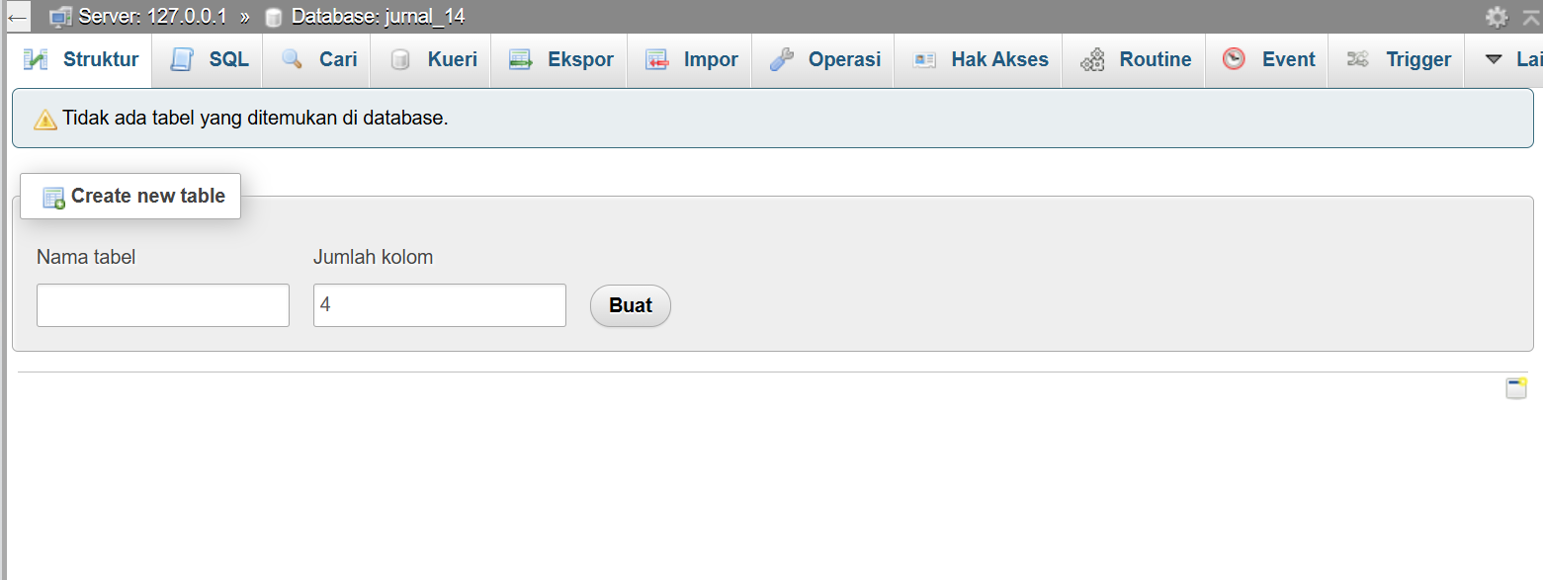

Migration table
Create_users_table.php
<?php

use Illuminate\Database\Migrations\Migration;
use Illuminate\Database\Schema\Blueprint;
use Illuminate\Support\Facades\Schema;

return new class extends Migration
{
/**
* Run the migrations.
*/
public function up(): void
{
Schema::create('users', function (Blueprint $table) {
$table->id();
$table->string('name');
$table->string('email')->unique();
$table->timestamp('email_verified_at')->nullable();
$table->string('password');
$table->string('role')->default('user');
$table->rememberToken();
$table->timestamps();
});

Schema::create('password_reset_tokens', function (Blueprint $table) {
$table->string('email')->primary();
$table->string('token');
$table->timestamp('created_at')->nullable();
});

Schema::create('sessions', function (Blueprint $table) {
$table->string('id')->primary();
$table->foreignId('user_id')->nullable()->index();
$table->string('ip_address', 45)->nullable();
$table->text('user_agent')->nullable();
$table->longText('payload');
$table->integer('last_activity')->index();
});
}

/**
* Reverse the migrations.
*/
public function down(): void
{
Schema::dropIfExists('users');
Schema::dropIfExists('password_reset_tokens');
Schema::dropIfExists('sessions');
}
};

Create_books_table.php
<?php

use Illuminate\Database\Migrations\Migration;
use Illuminate\Database\Schema\Blueprint;
use Illuminate\Support\Facades\Schema;

return new class extends Migration
{
/**
* Run the migrations.
*/
public function up(): void
{
Schema::create('books', function (Blueprint $table) {
$table->id();
$table->string('title');
$table->text('description');
$table->date('release_date');
$table->integer('rating');
$table->timestamps();
});
}

/**
* Reverse the migrations.
*/
public function down(): void
{
Schema::dropIfExists('books');
}
};

Models
Users.php
<?php

namespace App\Models;

use Illuminate\Foundation\Auth\User as Authenticatable;

class User extends Authenticatable
{
protected $fillable = [
'name','email','password','role'
];
}

Book.php
<?php

namespace App\Models;

use Illuminate\Database\Eloquent\Model;

class Book extends Model
{
protected $fillable = [
'title','description','release_date','rating'
];
}

Controllers
AuthController.php
<?php

namespace App\Http\Controllers;

use Illuminate\Http\Request;
use App\Models\User;
use Auth;

class AuthController extends Controller
{
public function login() {
return view('login');
}

public function register() {
return view('register');
}

public function doLogin(Request $request) {
if (Auth::attempt($request->only('email','password'))) {
return redirect('/home');
}
return back();
}

public function doRegister(Request $request) {
User::create([
'name'=>$request->name,
'email'=>$request->email,
'password'=>bcrypt($request->password),
'role'=>$request->role
]);
return redirect('/login');
}

public function logout() {
Auth::logout();
return redirect('/login');
}
}

BookController.php
<?php

namespace App\Http\Controllers;

use Illuminate\Http\Request;
use App\Models\Book;

class BookController extends Controller
{
public function index() {
$books = Book::all();
return view('home', compact('books'));
}

public function store(Request $request) {
Book::create($request->all());
return back()->with('success', 'Book created successfully!');
}

public function edit($id) {
$bookToEdit = Book::find($id);
$books = Book::all();
return view('home', compact('books', 'bookToEdit'));
}

public function update(Request $request, $id) {
$book = Book::find($id);
$book->update($request->all());
return redirect('/home')->with('success', 'Book updated successfully!');
}

public function destroy($id) {
Book::find($id)->delete();
return back()->with('success', 'Book deleted successfully!');
}
}

Middleware
AdminMiddleware.php
<?php

namespace App\Http\Middleware;

use Closure;

class AdminMiddleware
{
public function handle($request, Closure $next)
{
if (auth()->user()->role !== 'admin') {
abort(403);
}
return $next($request);
}
}

Web.php
<?php

use App\Http\Controllers\AuthController;
use App\Http\Controllers\BookController;

Route::get('/', function () {
return redirect('login');
});

Route::get('/login',[AuthController::class,'login']);
Route::post('/login',[AuthController::class,'doLogin']);

Route::get('/register',[AuthController::class,'register']);
Route::post('/register',[AuthController::class,'doRegister']);

Route::get('/logout',[AuthController::class,'logout']);

Route::middleware('auth')->group(function(){
Route::get('/home',[BookController::class,'index']);

Route::middleware('admin')->group(function(){
Route::post('/book',[BookController::class,'store']);
Route::get('/book/{id}/edit',[BookController::class,'edit']);
Route::put('/book/{id}',[BookController::class,'update']);
Route::delete('/book/{id}',[BookController::class,'destroy']);
});
});

Home.blade.php
<!DOCTYPE html>
<html lang="en">
<head>
<meta charset="UTF-8">
<meta name="viewport" content="width=device-width, initial-scale=1.0">
<title>Perpustakaan Tertutup</title>
<link href="https://cdn.jsdelivr.net/npm/bootstrap@5.3.2/dist/css/bootstrap.min.css" rel="stylesheet">
<style>
body {
background-color: #f8f9fa;
font-family: sans-serif;
}
.badge-role {
font-size: 0.8em;
text-transform: uppercase;
}
.table-header-dark {
background-color: #212529;
color: white;
}
.rating-badge {
background-color: #ffc107;
color: #000;
font-weight: bold;
padding: 0.35em 0.65em;
border-radius: 4px;
}
.action-btn {
font-size: 0.8rem;
padding: 0.25rem 0.5rem;
}
</style>
</head>
<body>

<div class="container mt-5">
<!-- Header -->
<div class="d-flex justify-content-between align-items-center mb-4">
<h2 class="fw-bold text-secondary">Perpustakaan Tertutup</h2>

<div class="d-flex align-items-center gap-2">
@php
$role = auth()->user()->role;
$roleColor = $role === 'admin' ? 'bg-danger' : 'bg-secondary';
@endphp
<span class="badge {{ $roleColor }} badge-role">{{ $role }}</span>
<span class="fw-semibold text-secondary">{{ auth()->user()->name }}</span>
<a href="/logout" class="btn btn-outline-secondary btn-sm ms-2">Logout</a>
</div>
</div>

<!-- Success Message -->
@if(session('success'))
<div class="alert alert-success alert-dismissible fade show" role="alert">
{{ session('success') }}
<button type="button" class="btn-close" data-bs-dismiss="alert" aria-label="Close"></button>
</div>
@endif

<!-- Add Book Form (Admin Only) -->
@if(auth()->user()->role == 'admin')
<div class="card mb-4 border-0 shadow-sm">
<div class="card-header bg-primary text-white custom-header">
{{ isset($bookToEdit) ? 'Edit Book' : 'Add New Book' }}
</div>
<div class="card-body">
<form method="POST" action="{{ isset($bookToEdit) ? '/book/' . $bookToEdit->id : '/book' }}" class="row g-2 align-items-center">
@csrf
@if(isset($bookToEdit))
@method('PUT')
@endif
<div class="col-md-3">
<input type="text" class="form-control" name="title" placeholder="Title" value="{{ isset($bookToEdit) ? $bookToEdit->title : '' }}" required>
</div>
<div class="col-md-3">
<input type="text" class="form-control" name="description" placeholder="Description" value="{{ isset($bookToEdit) ? $bookToEdit->description : '' }}" required>
</div>
<div class="col-md-2">
<input type="date" class="form-control" name="release_date" placeholder="dd/mm/yyyy" value="{{ isset($bookToEdit) ? $bookToEdit->release_date : '' }}" required>
</div>
<div class="col-md-2">
<input type="number" class="form-control" name="rating" min="1" max="5" placeholder="Rating" value="{{ isset($bookToEdit) ? $bookToEdit->rating : '' }}" required>
</div>
<div class="col-md-2">
<button class="btn btn-primary w-100 fw-bold">{{ isset($bookToEdit) ? 'Update Book' : 'Add Book' }}</button>
@if(isset($bookToEdit))
<a href="/home" class="btn btn-secondary w-100 fw-bold mt-1" style="font-size: 0.8rem;">Cancel</a>
@endif
</div>
</form>
</div>
</div>
@endif

<!-- Books Table -->
<div class="card border-0 shadow-sm">
<div class="card-header bg-transparent border-0 pb-0">
<h6 class="text-secondary">All Books</h6>
</div>
<div class="card-body">
<table class="table table-hover align-middle">
<thead class="table-dark">
<tr>
<th style="width: 50px;">#</th>
<th>Title</th>
<th>Description</th>
<th>Release Date</th>
<th>Rating</th>
<th>Created</th>
@if(auth()->user()->role == 'admin')
<th>Actions</th>
@else
<!-- Spacer for normal user if needed or just omission -->
@endif
</tr>
</thead>
<tbody>
@foreach($books as $index => $b)
<tr>
<td>{{ $index + 1 }}</td>
<td>{{ $b->title }}</td>
<td>{{ $b->description }}</td>
<td>{{ $b->release_date }}</td>
<td>
<span class="rating-badge">{{ number_format($b->rating, 1) }}</span>
</td>
<td>{{ $b->created_at->format('M d, Y') }}</td>
@if(auth()->user()->role == 'admin')
<td>
<div class="d-flex gap-1">
<!-- Edit Button -->
<a href="/book/{{ $b->id }}/edit" class="btn btn-warning btn-sm text-white action-btn">Edit</a>

<form method="POST" action="/book/{{ $b->id }}" onsubmit="return confirm('Are you sure?')">
@csrf
@method('DELETE')
<button class="btn btn-danger btn-sm action-btn">Delete</button>
</form>
</div>
</td>
@endif
</tr>
@endforeach
</tbody>
</table>
</div>
</div>

</div>

<script src="https://cdn.jsdelivr.net/npm/bootstrap@5.3.2/dist/js/bootstrap.bundle.min.js"></script>
</body>
</html>

Login.blade.php
<!DOCTYPE html>
<html lang="id">
<head>
<meta charset="UTF-8">
<meta name="viewport" content="width=device-width, initial-scale=1.0">
<title>Masuk - Perpustakaan</title>
<link href="https://cdn.jsdelivr.net/npm/bootstrap@5.3.2/dist/css/bootstrap.min.css" rel="stylesheet">
<style>
body {
background-color: #f8f9fa;
font-family: 'Inter', sans-serif;
}
.login-card {
border: none;
border-radius: 12px;
box-shadow: 0 4px 6px -1px rgba(0, 0, 0, 0.1), 0 2px 4px -1px rgba(0, 0, 0, 0.06);
}
.login-header {
background: linear-gradient(135deg, #4f46e5 0%, #2563eb 100%);
color: white;
padding: 24px;
border-top-left-radius: 12px;
border-top-right-radius: 12px;
text-align: center;
font-weight: 700;
letter-spacing: 1px;
}
.btn-primary {
background-color: #4f46e5;
border-color: #4f46e5;
}
.btn-primary:hover {
background-color: #4338ca;
border-color: #4338ca;
}
</style>
</head>
<body class="d-flex align-items-center min-vh-100">

<div class="container">
<div class="row justify-content-center">
<div class="col-md-5 col-lg-4">
<div class="card login-card">
<div class="login-header">
LOGIN
</div>
<div class="card-body p-4">
<form method="POST" action="/login">
@csrf
<div class="mb-3">
<label class="form-label fw-bold">Email</label>
<input type="email" name="email" class="form-control" placeholder="Masukkan email anda" required>
</div>
<div class="mb-4">
<label class="form-label fw-bold">Password</label>
<input type="password" name="password" class="form-control" placeholder="Masukkan password" required>
</div>
<button class="btn btn-primary w-100 py-2 fw-bold">Masuk</button>
</form>
</div>
<div class="card-footer text-center bg-white border-0 pb-4">
<p class="text-muted mb-0">Belum punya akun? <a href="/register" class="text-decoration-none text-primary fw-bold">Daftar sekarang</a></p>
</div>
</div>
</div>
</div>
</div>

</body>
</html>

Register.blade.php
<!DOCTYPE html>
<html lang="id">
<head>
<meta charset="UTF-8">
<title>Register</title>
<link href="https://cdn.jsdelivr.net/npm/bootstrap@5.3.2/dist/css/bootstrap.min.css" rel="stylesheet">
</head>
<body class="bg-light">

<div class="container">
<div class="row justify-content-center mt-5">
<div class="col-md-4">
<div class="card shadow">
<div class="card-header bg-success text-white text-center">
REGISTER
</div>
<div class="card-body">
<form method="POST" action="/register">
@csrf
<div class="mb-2">
<label>Nama</label>
<input type="text" name="name" class="form-control" required>
</div>
<div class="mb-2">
<label>Email</label>
<input type="email" name="email" class="form-control" required>
</div>
<div class="mb-2">
<label>Password</label>
<input type="password" name="password" class="form-control" required>
</div>
<div class="mb-3">
<label>Role</label>
<select name="role" class="form-control">
<option value="user">Normal User</option>
<option value="admin">Admin</option>
</select>
</div>
<button class="btn btn-success w-100">Register</button>
</form>
</div>
<div class="card-footer text-center">
<a href="/login">Sudah punya akun?</a>
</div>
</div>
</div>
</div>
</div>

</body>
</html>

Link : https://drive.google.com/drive/folders/1OOIsTS3TO2tNM06R4IA3UfD-kypNJwoT?usp=sharing

